Lazy loading means delaying the loading of related data, until you specifically request for it.

For lazy loading Navigation property should be defined as public and virtual. Context class will not do lazy loading if property is not defined as virtual.

When using POCO entity types, lazy loading is achieved by creating instance of derived proxy types and then overriding virtual properties.

When you have vast data go for lazy loading

The queries in this case will be executed 4 times internally (11,22,33,44) Cids from categories

TABLE DATA

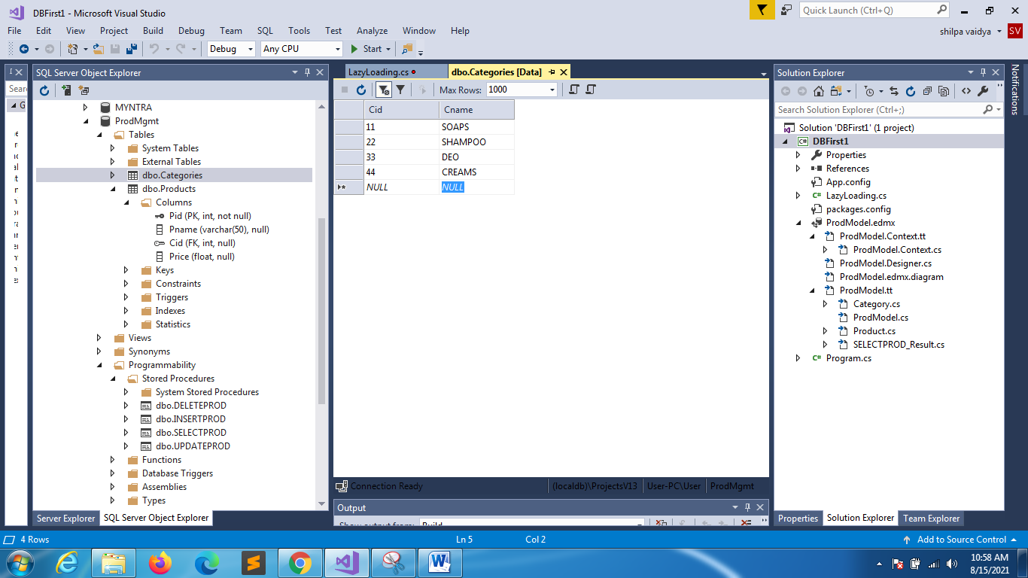 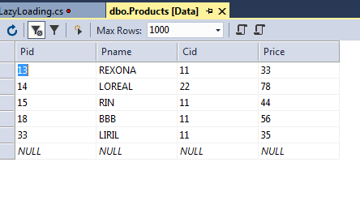

using System;

using System.Collections.Generic;

using System.Linq;

using System.Text;

using System.Threading.Tasks;

namespace DBFirst1

{

    class LazyLoading

    {

        static void Main(string[] args)

        {

            ProdMgmtEntities db = new ProdMgmtEntities();

            foreach(Category c in db.Categories)

            {

                Console.WriteLine("{0}\t{1}\t",c.Cid,c.Cname);

                Console.WriteLine("____________________");

                foreach(Product p in c.Products)

                    Console.WriteLine(p.Pname);

                Console.WriteLine("____________________");

            }

        }

    }

}